Using SToRM — A Short Primer

INTRODUCTION

The study of natural river changes and the interference of man in natural water bodies is a difficult but important activity, as increasing and shifting populations place more demands on the natural sources of fresh water. Although the basic mechanical principles for these studies are well established, a complete analytical solution is not known but for the most basic cases. The complexity required to describe flow movement and its interaction with its boundaries, which are themselves deformable, have precluded the development of closed form solutions to the governing equations that describe the mechanical behavior of fluid and solid-fluid mixtures. As a result, alternative techniques have been developed to provide quantitative predictions of these phenomena as an aide to engineering projects and river restoration efforts. Modeling is one of such techniques.

There are two types of models: mathematical models and physical models (sometimes also called scale models). This short primer concerns mathematical and numerical modeling, which is based on computation techniques, as opposed to physical modeling, which is based on traditional laboratory techniques and measurement.

Numerical modeling has become very popular in the past few decades, mainly due to the increasing availability of more powerful and affordable computing platforms. Much progress has been made, particularly in the fields of sediment transport, water quality, and multi-dimensional fluid flow and turbulence. SToRM (System for Transport and River Modeling) is a numerical model that uses the two-dimensional depth-averaged equations, also referred to as the shallow water equations (SWEs), to simulate environmental surface waters. Depth-averaged modeling using the SWEs is widely used in rivers, lakes, estuaries, and coastal flows, and has been shown to predict many flow features well. With the advent of fast desktop computers it has become computationally efficient, and the availability of large-scale, high-resolution data collection techniques (such as LiDAR) has matched the models’ data requirements. Within this framework, SToRM was developed to simulate flows in natural rivers, with emphasis on wetting and drying effects in rapidly-varying, unsteady flows.

This short primer provides the necessary information to understand some of the basic parameters necessary to run the model SToRM in the graphical user interface MD_SWMS. Prefecing it, there are a few sections that present some general aspects concerning numerical modeling. This presentation is very succinct and contains the very minimum of mathematical equations and jargon. This primer is not meant to substitute for basic texts in hydraulics and numerical methods, and the reader is strongly cautioned against using any computer model, including SToRM, without having the proper background in general fluid dynamics, free surface hydraulics, and at least some understanding of the basic principles of calculus and numerical methods.

NUMERICAL MODELING

In general, numerical models are used for the same reasons as physical models, i.e., the problem at hand cannot be solved directly for the prototype. The process from prototype data to the modeling and to final interpretation of the results (i.e., the modeling cycle) is complex and prone to many errors. Careful engineering judgment must be exercised at every step. The modeling cycle is schematically represented in Fig. 1.

The prototype is the reality to be studied. It is defined by data and by knowledge. The data represents boundary conditions, such as bathymetry, water discharges, sediment particle size distributions, vegetation types, etc. The knowledge contains the physical processes that are known to determine the system’s behavior, such as flow turbulence, sediment transport mechanisms, mixing processes, etc. Understanding the prototype and data collection constitute the first step of the cycle.

In the first interpretation step, all the relevant physical processes that were identified in the prototype are translated into governing equations that are compiled into the mathematical model. A mathematical model, therefore, constitutes the first approximation to the problem. It is the pre-requisite for a numerical model. At this time many simplifying approximations are made, such as steady versus unsteady and one- versus two- versus three-dimensional formulations; simplifying descriptions of turbulence; etc. In water resources, one usually (but not always) arrives to the set-up of a boundary value problem whose governing equations contain partial differential equations and nonlinear terms.

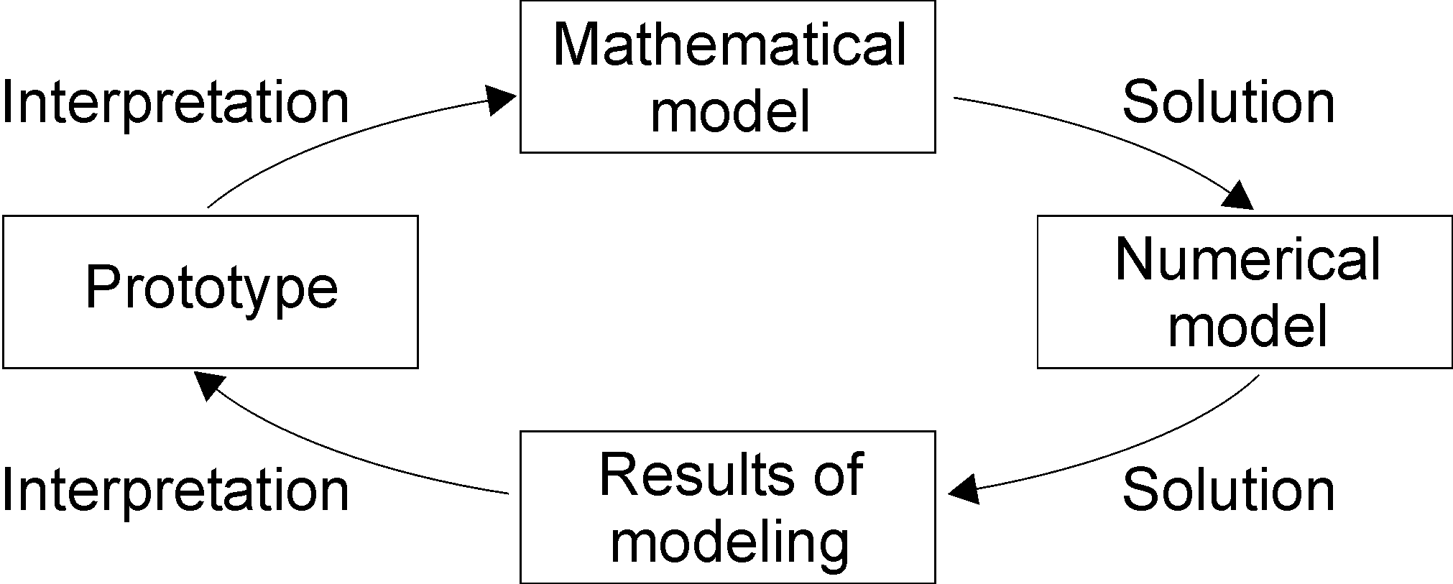

Figure 1. Computer modeling cycle, from prototype to modeling results. The cycle starts with the prototype being studied and ends with the interpretation of model results to withdraw conclusions about it.

Next, a solution step is required to solve the mathematical model. The numerical model embodies the numerical techniques used to solve the set of governing equations that form the mathematical model. In this step one chooses, for example, finite difference versus finite element versus finite volume discretization techniques; selects the approach to deal with the nonlinear terms; etc. Note that this is a further approximating step, because the partial differential equations are transformed into algebraic equations, which are approximate but not equivalent to the former.

Another solution step involves the solution of the numerical model in a computer, i.e. using SToRM, and provides the results of modeling. This step embodies further approximations and simplifications, such as those associated with unknown boundary conditions, imprecise bathymetry, unknown water and/or sediment discharges, friction factors, etc.

Finally, the data needs to be interpreted and placed in the appropriate prototype context. This last step closes the modeling cycle and ultimately provides the answer to the problem that drives the modeling efforts.

The choice of model for each specific problem should take into account the requirements of the problem, the knowledge about the system, and the data available. On one hand, the model must take into account all the significant phenomena that are known to occur in the system and that will influence the aspects that are being studied. On the other hand, model complexity is limited by the available data. At this time, there is no universal model that can be applied to every problem, and such may even not be a desirable thing to have. The specific requirements of each problem should be analyzed and the model chosen should reflect this analysis in its features and complexity. There is no lack of computer models for engineers to choose from. The success of a study depends, to a large degree, on the engineer’s understanding of fluvial processes, associated theories, and the capabilities and limitations of computer models. In many cases, the selection of a modeler is more important than the selection of the computer model.

MATHEMATICAL MODELING

The flow phenomena in natural rivers are three-dimensional, especially those at or near a meander bend, local expansion and contraction, or a hydraulic structure. Turbulence is an essentially three-dimensional phenomenon, and three-dimensional models are particularly useful for the simulation of turbulent heat and mass transport. These models are usually based on the Reynolds-averaged form of the Navier-Stokes equations, using additional equations of varied degree of complexity for the turbulence closure.

The derivation of the governing equations can be found in many basic textbooks on fluid dynamics, therefore they will not be presented here. They are the Navier-Stokes equations, which represent the statement of Newton’s second law for fluids, i.e. the conservation of momentum. Additionally, a continuity equation representing the conservation of mass is also used. Body forces are usually included in these equations, such as gravitational, buoyancy, and Coriolis forces, or any other that may be present (such as extra loss terms due to the presence of vegetation, for example). Additionally, special equations may be used to model the effects of turbulence. For example, one of the commonly used turbulence closure techniques is given by the k-ε model, but there are many other alternative choices.

In free surface flows, an additional equation is required to solve for the position of the free surface. A common technique is to use a rigid lid approximation, in which the flow is solved in the same manner as pressurized flow by assuming a rigid frictionless boundary at the approximate position where the free surface is located. This eliminates the need to use an additional differential equation to compute the free surface position: the free surface location can be computed from the flow pressure by extrapolating (or interpolating) to the location where the hydrodynamic pressure equals the atmospheric pressure. Accuracy is lost when the free surface location differs significantly from the rigid lid location (say, by 10% or more of the flow depth), which may occur in bends and around obstacles.

Three-dimensional modeling is a very powerful tool in river engineering, but it also has high computational demands (i.e., faster computers with large memory space are needed). It also requires vast amounts of data for proper model set-up, which take time and are expensive to obtain. These requirements have until recently limited their use, but newer, faster, and more affordable computers, together with new data collection instrumentation, may overcome these limitations in the near future.

Two-dimensional models for flow and sediment transport are becoming widely used. Two-dimensional models can be classified into two-dimensional vertically averaged and two-dimensional horizontally averaged models. The former scheme is used where depth-averaged velocity or other hydraulic parameters can adequately describe the variation of hydraulic conditions across a channel. The latter scheme is used where width-averaged hydraulic parameters can adequately describe the variation of hydraulic conditions in the vertical direction. Most two-dimensional sediment transport models are depth-averaged models, and SToRM belongs to this category of models.

Two-dimensional depth-averaged models result from vertically averaging the governing equations using a few simplifying assumptions. First, integrating the continuity equation (conservation of mass), making use of the kinematic condition at the free surface and the fact that the normal component of the velocity must vanish at the solid bed, one obtains

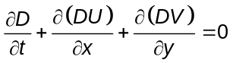

where the depth-averaged velocities are defined as

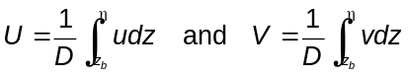

where z_{b} denotes the bed elevation and η is the free surface elevation (see Fig. 2 for the meaning of the other symbols). The momentum equations can be averaged in the same way. Including the Coriolis and pressure terms, and after further simplification, the depth-averaged momentum equations become

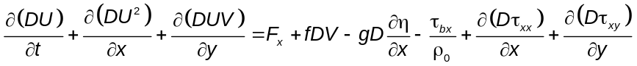

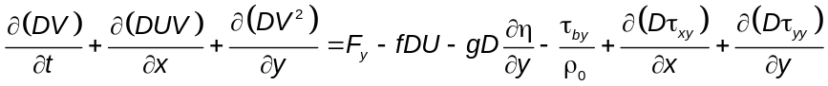

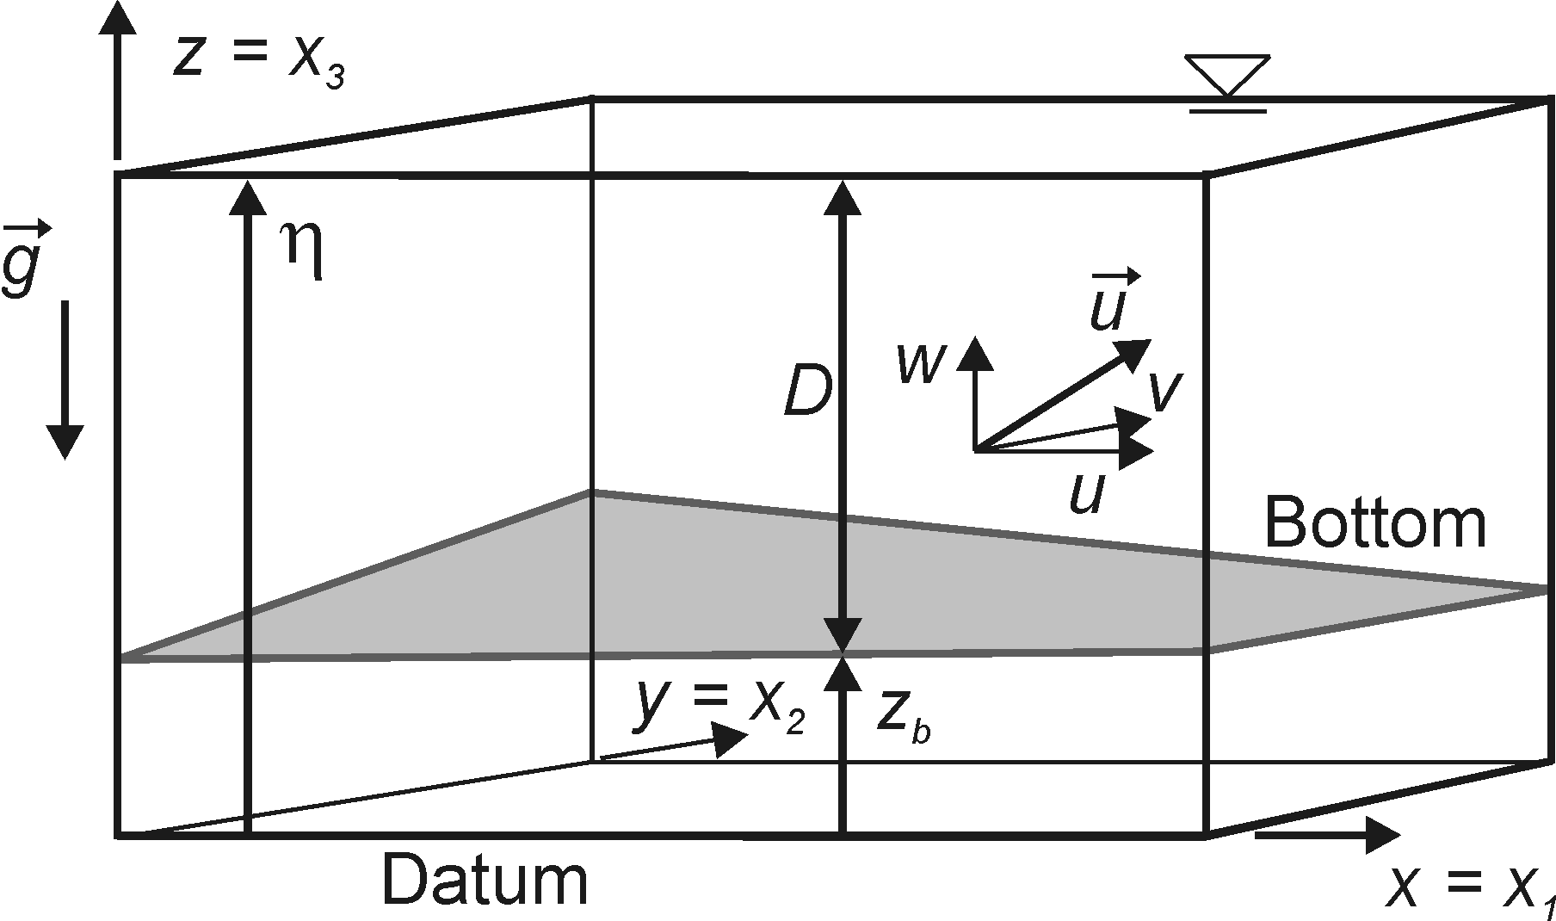

Figure 2. Sketch showing the coordinate system used and the definition of some of the variables. Note that u = u₁, v = u₂, and w = u₃.

In the equations above, f is theCoriolis parameter (= 2Ω sinφ, where Ω is the angular rate of earth’s revolution and φ is the geographic latitude), F_{i} are driving forces (i = x,y), ρ₀ is the density of water, and τ_{bi} are the bottom stresses (i = x,y). They are sometimes called the shallow-water equations or the depth-averaged Navier-Stokes equations. The cross-stresses τ_{ij} include viscous friction, turbulent friction, and the nonlinear terms resulting from the vertical averaging process, which are usually called the radiation stresses:

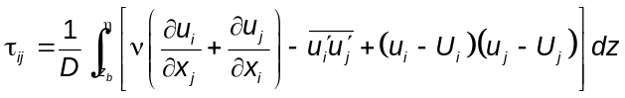

In most natural bodies of water, the molecular viscosity terms can be safely neglected in comparison with the turbulence terms. The radiation stresses are often neglected, but they represent important physical phenomena. For example, in bends they are at least partly responsible for shifting the high velocity part of the flow profile from the inner bank at the upstream region to the outer bank at the downstream region of the bend. In general, however, these terms are collapsed in the form of diffusion coefficients and written as

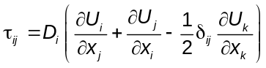

where δ_{ij} is the Kronecker delta (= 1 if i = k, 0 otherwise), and D_{i} is a diffusion coefficient in the i^{th} direction (in general, D₁ = D₂ = D_{H}).

In turbulent flow, the diffusion coefficients can be prescribed or computed from any of the many existing turbulence models, and the bottom shear stresses are assumed to have the same direction of the depth-mean velocity and proportional to the square of its magnitude:

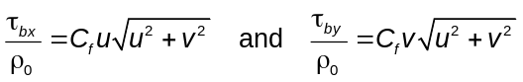

where C_{f} is the standard friction (drag) coefficient 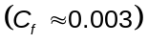. Note that the bed shear stresses can be also written in terms of the Manning’s roughness coefficient, n, or in terms of Chézy’s roughness coefficient, C:

The driving forces remaining in the SWEs include such effects as atmospheric pressure gradients, wind stresses, density gradients, and tidal stresses. The SWEs can be written in many possible forms. Those forms may include different terms than the ones considered above (corresponding to other physical effects), or may be written in terms of curvilinear coordinates, for example. Many other aspects that are of interest, but that are outside the scope of this monograph.

One-dimensional models use quantities that are cross-sectionally averaged. Most of the sediment transport models used in river engineering are one-dimensional, especially those used for long-term simulation of a long river reach. One-dimensional models generally require the least amount of field data for calibration and testing. The numerical solutions are more stable and require the least amount of computer time and capacity. One-dimensional models are not suitable, however, for simulating truly two- or three-dimensional local phenomena.

One-dimensional models are usually based on the same conservation principles as the multi-dimensional models described in the previous two sections. Many are based on the de Saint Venant equations, but there others, such as those based on neural networks. They assume that all the main variables are uniform across the cross section, that the bed slope is small, and all curvature effects are neglected.

NUMERICAL METHODS

In most cases there are no known analytical solutions for the governing equations described in the previous sections, except for the simplest of geometric configurations and flow regimes. However, there is a vast body of numerical mathematics that can be used to find the solutions for an alternative, but approximate, numerical (discrete) statement to the continuous problem expressed by the governing partial differential equations and their corresponding boundary conditions. The resulting numerical description of the mathematical model at hand consists of a set of algebraic equations that can be programmed and solved in a computer: the numerical model.

This section will offer a brief description of some of the methods most commonly used to solve the fluid flow equations. The techniques of interest are those based on some type of gridded discretization of the problem at hand, in which the continuous variables for which the solution is sought are solved only at specific discrete locations of the physical domain. The algebraic equations that form the numerical model are functions of those discrete quantities.

For the same problem (i.e., the same set of differential governing equations and boundary conditions), it is possible to obtain very distinct sets of algebraic numerical equations, depending on the technique used to discretize the equations. This chapter will only be concerned with three such techniques: finite differences, finite elements, and finite volumes (used in SToRM). In practice, there are many other techniques available to numerically solve the fluid flow equations. On the other hand, it is possible to state certain finite difference and finite volume techniques as a subset of the finite element technique. We will not deal with these fine points here, which are fully covered in standard textbooks in computational fluid dynamics.

As mentioned above, the translation from continuous to discrete replaces one problem (the continuous formulation) by another (the discrete formulation). The latter should provide a solution that should converge to the solution of the former. In this context, convergence is a term that denotes a relationship between the numerical and the analytical solutions. Convergence should be obtained as the grid spacing (Δx in one-dimensional problems) and time step (Δt in unsteady problems) are refined, i.e., as 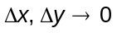.

Convergence is ensured by Lax’s theorem—which has been proven for linear problems only, but which is nonetheless at the foundation of computational fluid dynamics—which states that consistence and stability are sufficient to ensure the convergence of a numerical scheme. Consistence is a term applied to the algebraic equations: a numerical scheme is said to be consistent with the partial differential equation if its truncation error disappears in the limit . Stability is a term that applies to the numerical solution itself: a solution is stable if it remains bounded at all times during the computations.

Finite difference methods are probably the most simple and most common methods employed in fluid flow models, as well as in other disciplines requiring the numerical solution of partial differential equations. They are based on the approximation of the individual derivative terms in the equations by discrete differences, thus converting them into sets of simultaneous algebraic equations with the unknowns defined at discrete points over the entire domain of the problem. For example, the partial derivative of u(x,y) at point (i,j) of the discretized domain in the x-direction can be written as

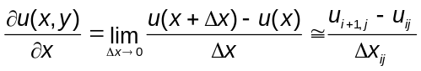

and similarly for the y-direction (see Fig. 3). Note that the above equation does not represent the only possible choice of discretization. For example, without loss of mathematical rigor one could choose instead

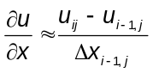

The first equation is called forward difference and the second is called backward difference. One could define central differences, or even use multiple Δx to define differential operators that span many grid nodes. On the other hand, the grid can be quite complex. Curvilinear non-orthogonal grids are indeed used to describe complex flow domains, but the corresponding differential operators are also more complicated than the ones shown above.

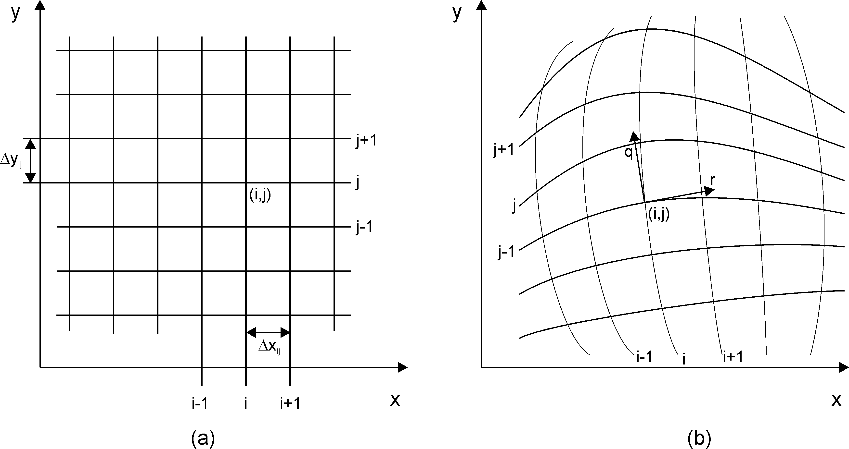

Figure 3. Typical mesh systems used in finite difference methods. (a) Cartesian orthogonal mesh; (b) curvilinear mesh (not necessarily orthogonal). The local coordinate system for point (i,j) in (b) is defined by the unit vectors q and r, which are tangent to the grid lines. The points where the variables are defined are located at the intersection of the grid lines.

Finite element methods have been used successfully for fluid flow problems since the 1960’s. They are particularly useful to solve problems with complex geometries, as they do not require the structured grid system needed in finite difference techniques. In an unstructured grid, the computational nodes do not need to be defined in an ordered manner, as opposed to structured grids where each node is identified by an (i,j) pair (or (i,j,k) trio in three-dimensional models), such as those shown in Fig. 3. An example of unstructured grid is shown in Fig. 4.

There are two main approaches for the formulation of finite element methods: variational methods and weighted residual methods. In variational methods, the variational principle for the governing equation is minimized. In general fluid mechanics problems, exact forms of the variational principles for the governing nonlinear equations are difficult to find (unlike in the linear equations encountered in solid mechanics), therefore weighted residual methods are much more popular. Residual methods are based on minimizing some sort of error, or residual, of the governing equations. Let R be the residual of the differential equation (for example, R = Δ² ψ). Mathematically, minimization of R to zero can be achieved by orthogonally projecting R on a subspace of weighting functions, W_{f}, i.e., by taking the inner product of the residual and the weighting functions:

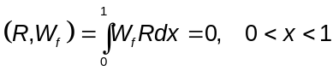

This process provides a mathematical framework to derive algebraic equations for any differential equation.

In finite element methods, the mathematical domain is divided into non-overlaping polyhedral subdomains (the elements) and the above equation is enforced in each subdomain, taking into consideration the boundary conditions. Within each element, the dependent variables are approximated by interpolating functions, which are determined by the type of element used. Some of the most commonly used elements for fluid mechanics applications are presented in Fig. 5.

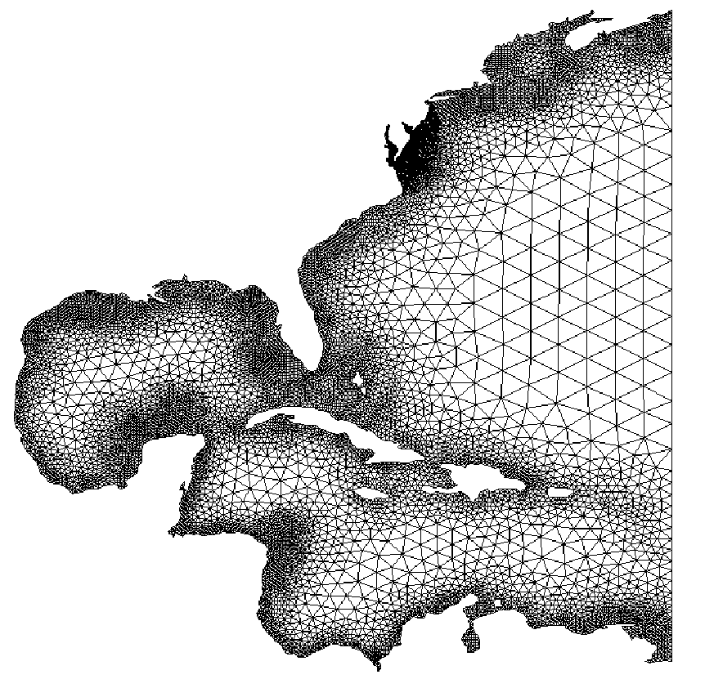

Figure 4. Finite element mesh for part of the American Atlantic coast, as generated by the 2D automatic finite element grid generator software gredit, CCALMR, Oregon Health and Science University. Note that the darker areas represent a very high density of triangles that cannot be resolved at the scale used in this figure.

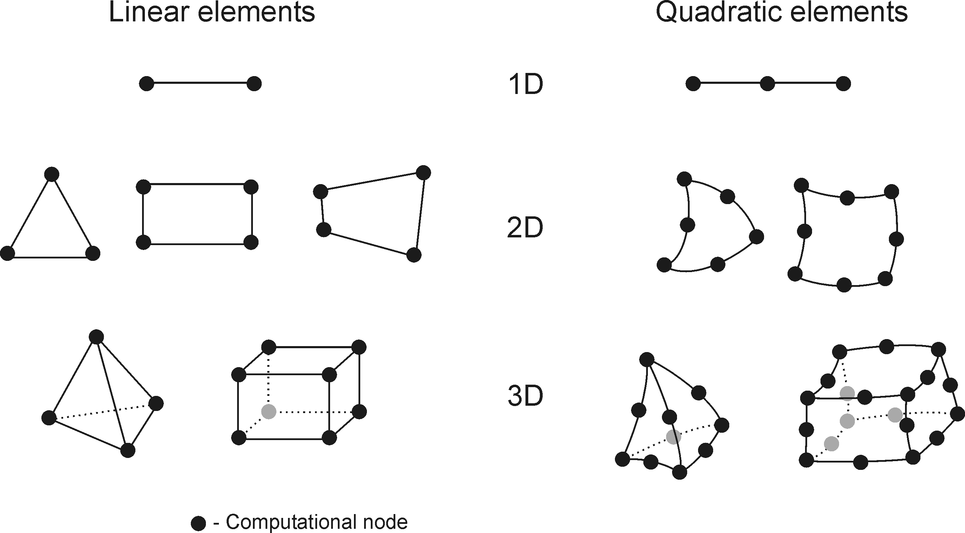

Figure 5. Some of the more common finite elements used in fluid flow modeling.

SToRM uses a finite volume method. Finite volume methods use conservation laws, i.e., the integral forms of the governing equations. The domain of computation is subdivided into an arbitrary number of control volumes and the equations are discretized by accounting for the several fluxes crossing the control volume boundaries. There are two main types of techniques to define the shape and position of the control volumes with respect to the discrete grid points where the dependent variables are calculated: the node-centered scheme and the cell-centered scheme. Both schemes are schematically pictured in Fig. 6. The node-centered scheme places the grid nodes at the centroids of the control volume, making the control volumes “identical” to the grid cells. In cell-centered schemes, the control volume is formed by connecting adjacent grid nodes.

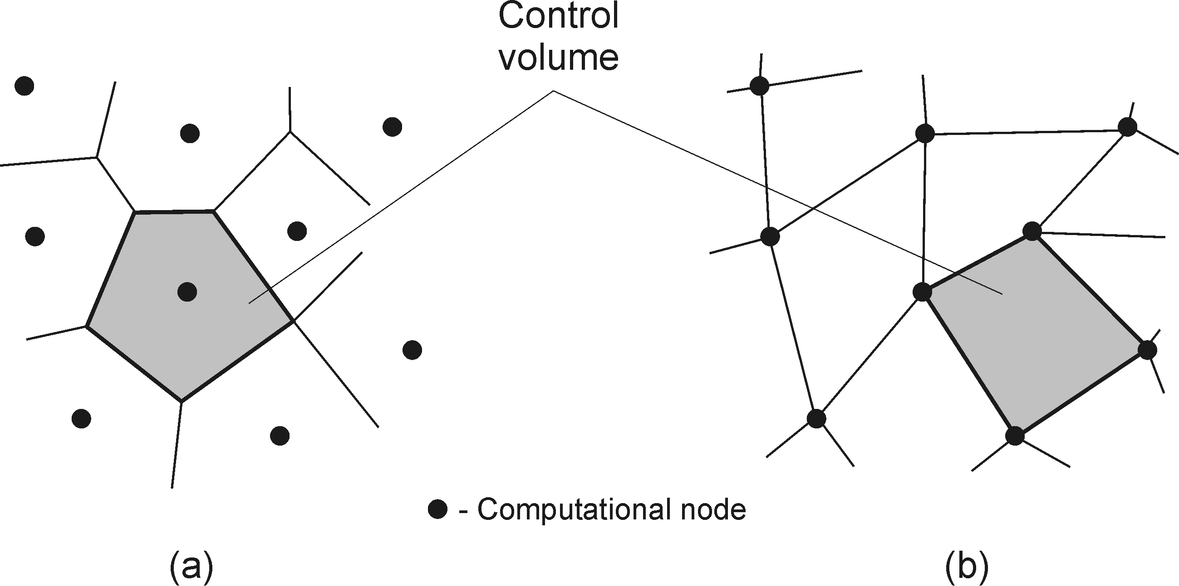

Figure 6. Representation of the control volumes formed by node-centered (a) and cell-centered (b) formulations used in finite volume discretizations.

The main advantage of finite volume methods is that the spatial discretization is done directly in the physical space, without the need to make any transformations between coordinate systems. It is a very flexible method that can be implemented in both structured and unstructured grid systems. Because the method is based directly on physical conservation principles, mass, momentum, and energy are automatically conserved by the numerical scheme.

There are many other numerical discretization techniques that, for certain specific applications, offer significant advantages. Some of them do not use conventional discretization grids as those described above. However, it is out of the scope of this monograph to describe them all.

DATA REQUIREMENTS

In general, the basic data requirements for loose boundary hydraulic models can be grouped in three broad categories: geometric data, hydraulic data, and sediment data. These data establish the boundary conditions necessary to solve the governing equations and are an integral part of a model. The term model thus refers to the ensemble of the set of governing equations, their numeric solution technique, its implementation in a computer program, and the data that defines the prototype. In practice, data collection is more often the responsibility of the user of the computer program that implements the numerical part of the model, or of someone else that then conveys that data to the user. However, data collection and preparation is no less important than the computer model itself, and often plays the dominant role in determining the accuracy and applicability of the final numerical solutions generated by the computer.

The geometry data defines the topography of the reach to be simulated, i.e., the channel bed, banks, and flood plains. In two- and three-dimensional models, the data is most often presented as a set of points given by its x, y, and z coordinates. The data is then interpolated to the locations of the grid nodes used in the discretization of the problem. Interpolation may be done using standard triangulation techniques, or with more sophisticated techniques, such as kriging. In river channels, special techniques are often used that, in the interpolation process, emphasize the contribution of the data points along the flow streamlines, as they have the potential of better capturing the longitudinal characteristics of the river bed (i.e., the meandering of the thalweg).

In one-dimensional models, the geometry is usually defined by cross sections. Each cross section is a line representing a particular section of the modeled reach and is given by a set of points, each defined by a lateral distance and a bed elevation above a common datum. This line provides the information about the section shape and the locations of the subchannels, and should be taken between locations well above the highest stage levels. It should also be taken perpendicularly to the flow streamlines. Additionally, the distance between the cross sections needs to be given, and this distance must be collected along the flow streamlines. Under bankfull conditions, this distance can be taken along the channel’s thalweg, but this may vary under flooding conditions. Multi-dimensional models generally use the same type of data, but require much more dense surveys.

Examples of typical data sets collected to match different types of model requirements are shown in Fig. 7. In one-dimensional modeling, one is usually interested in having a cross-sectional description of the river reach. The data shown at the left of Fig. A is a typical example of such an approach. The black dotted line was added to indicate the approximate location of the shoreline, delineating the boundary between points with low elevation (in blue) and high elevation (in red). Note the presence of an island. The cross sections somewhat extend past these limits and over the dry island to allow the possibility of modeling flows with higher discharge, where those areas may become submerged.

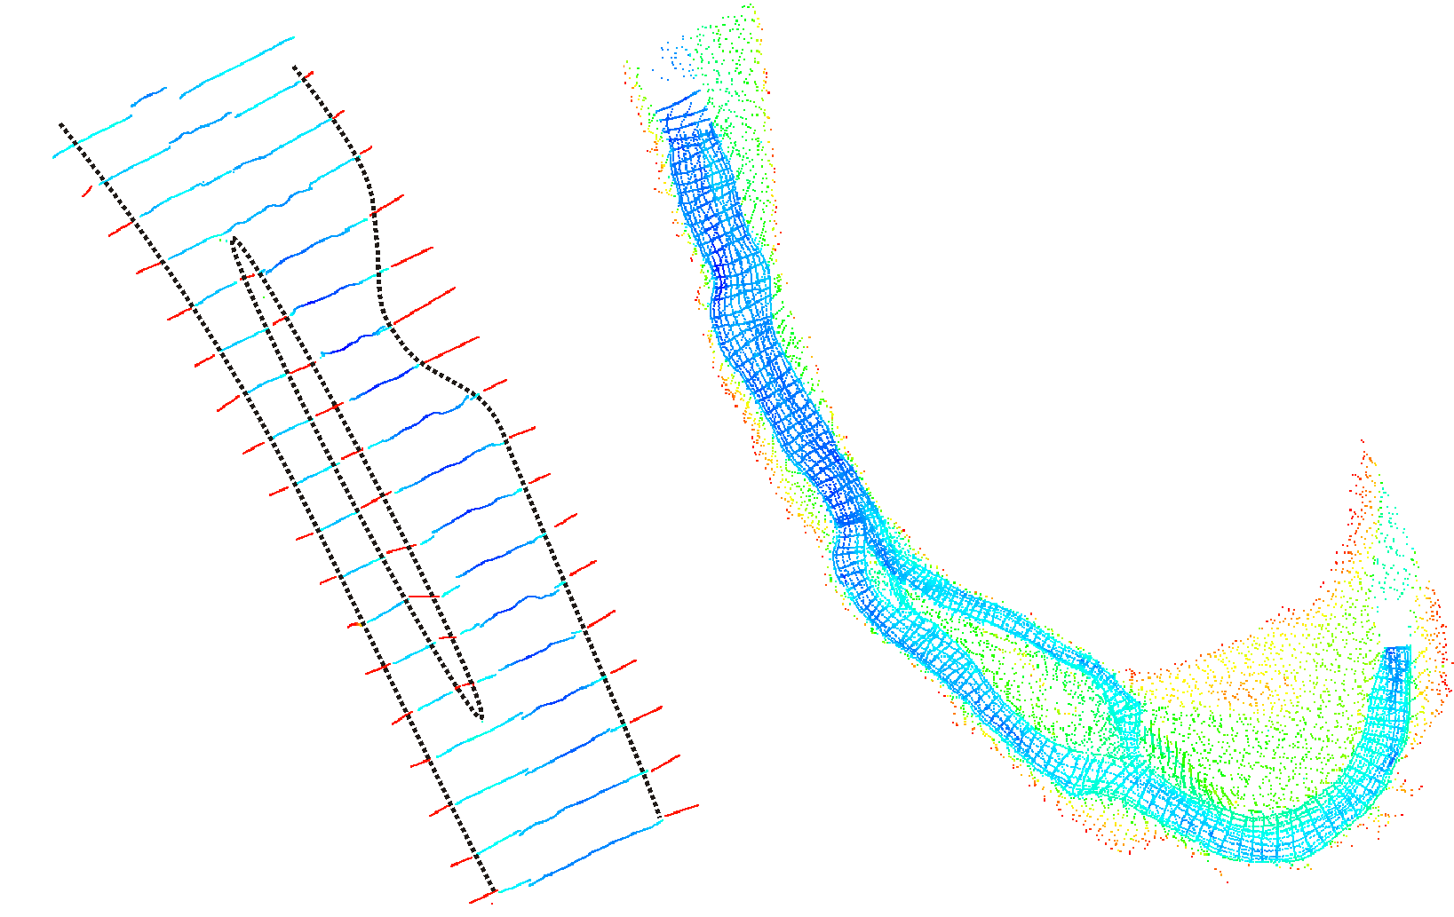

Figure 7. Example of river survey approaches. Left: cross section survey typically used in one-dimensional models; right: survey with unordered data with high density of survey data points. Color indicates bed elevation, lower elevations in blue and higher elevations in red.

The survey data shown at the right of Fig. 7 is much denser and the points are randomly distributed. The denser data is necessary for two- and three-dimensional modeling, where a more detailed description of the topography is needed. The blue points show the actual wet area of the reach. This part of the survey was done using a boat with sounding equipment, and the path followed by the vessel is reflected in the location of the blue survey points. As before, additional survey data was collected above the water line, as it might be needed for model runs with higher water discharge.

Hydraulic data encompasses the necessary upstream and downstream flow conditions, as well as friction factors and local head losses. Subcritical flows require the flow discharge at the upstream boundary and the stage at the downstream end, while supercritical flows require both the discharge and the stage at the upstream boundary (the analysis leading to this result can be found in any standard hydraulics textbook). In two- and three-dimensional flows this is equivalent to prescribing flow velocity field at the upstream, and a stage at the downstream boundary. Because usually only the upstream discharge is known, a vector velocity field must be synthesized, which is usually done by distributing the discharge proportionally to the conveyance along each node of the computational boundary, and then fitting a logarithmic profile along the vertical direction. Thus, any number of hydrographs can be discretized on an arbitrarily complex computational domain.

The stage can be defined in a number of ways. Stage-discharge rating curves, an elevation hydrograph, or a water-surface-slope hydrograph are common ways to achieve this purpose. More complex conditions may be defined in the case when the downstream boundary is a dam. In such cases, the reservoir operational scheme may be used. When the dam outlet works are used, relations for the gates and spillways may have to be employed.

Friction factors play an important role in determining stages and flow velocities, and must be given in the form of numerical values associated with particular regions of the bed, or in the form of relations that allow their representation as a function of other parameters—usually using hydraulic and/or sediment quantities. Local energy loss coefficients must also be given, such as those due to channel bends, natural or man-made obstacles to the flow, bridge piers and abutments, etc. Once again, these may be prescribed, or they may be calculated, and commonly require iterative calibration procedures.

Sediment data encompasses all the necessary information for sediment transport computations. The sediment inflow hydrograph must be given at the inflow boundaries. For two- and three-dimensional models it is also necessary to specify the sediment concentration distribution along those boundaries, as well as the separation between bed load and suspended load. The sediment particle-size distributions are also needed. Bed size distributions need also to be determined for each computational grid node (or for each cross section, in the case of one-dimensional models). Additionally, especially in the case of scour computations and bank widening, it is also necessary to provide the underlying bed material size distribution. Water temperature variations must also be prescribed or modeled, because they have an indirect impact on sediment transport via the sediment particles’ fall velocities.

In practice, it is difficult to determine a priori some of the hydraulic parameters necessary for a successful simulation. For that reason, usually there is a model calibration stage in which stage and discharge observations along the study reach are used to adjust the values of those parameters, such as bed roughness, discharge coefficients, or other parameters particular to the model employed. Similarly, there should be a calibration stage for the sediment transport calculations. Observations of the sediment outflow quantities, of variations in channel width and bed elevation, and of changes in sediment particle-size distributions can be used to properly adjust model parameters.

APPLICATION OF MODELS IN RIVER HYDRAULICS

Just as in many other areas of application, the complexity and variety of the factors involved in river phenomena requires a careful and methodical approach to their modeling, with large support of field observations and prototype data. A step-by-step approach is recommended to deal with these issues. A schematic view of the entire process is presented in Fig. 8.

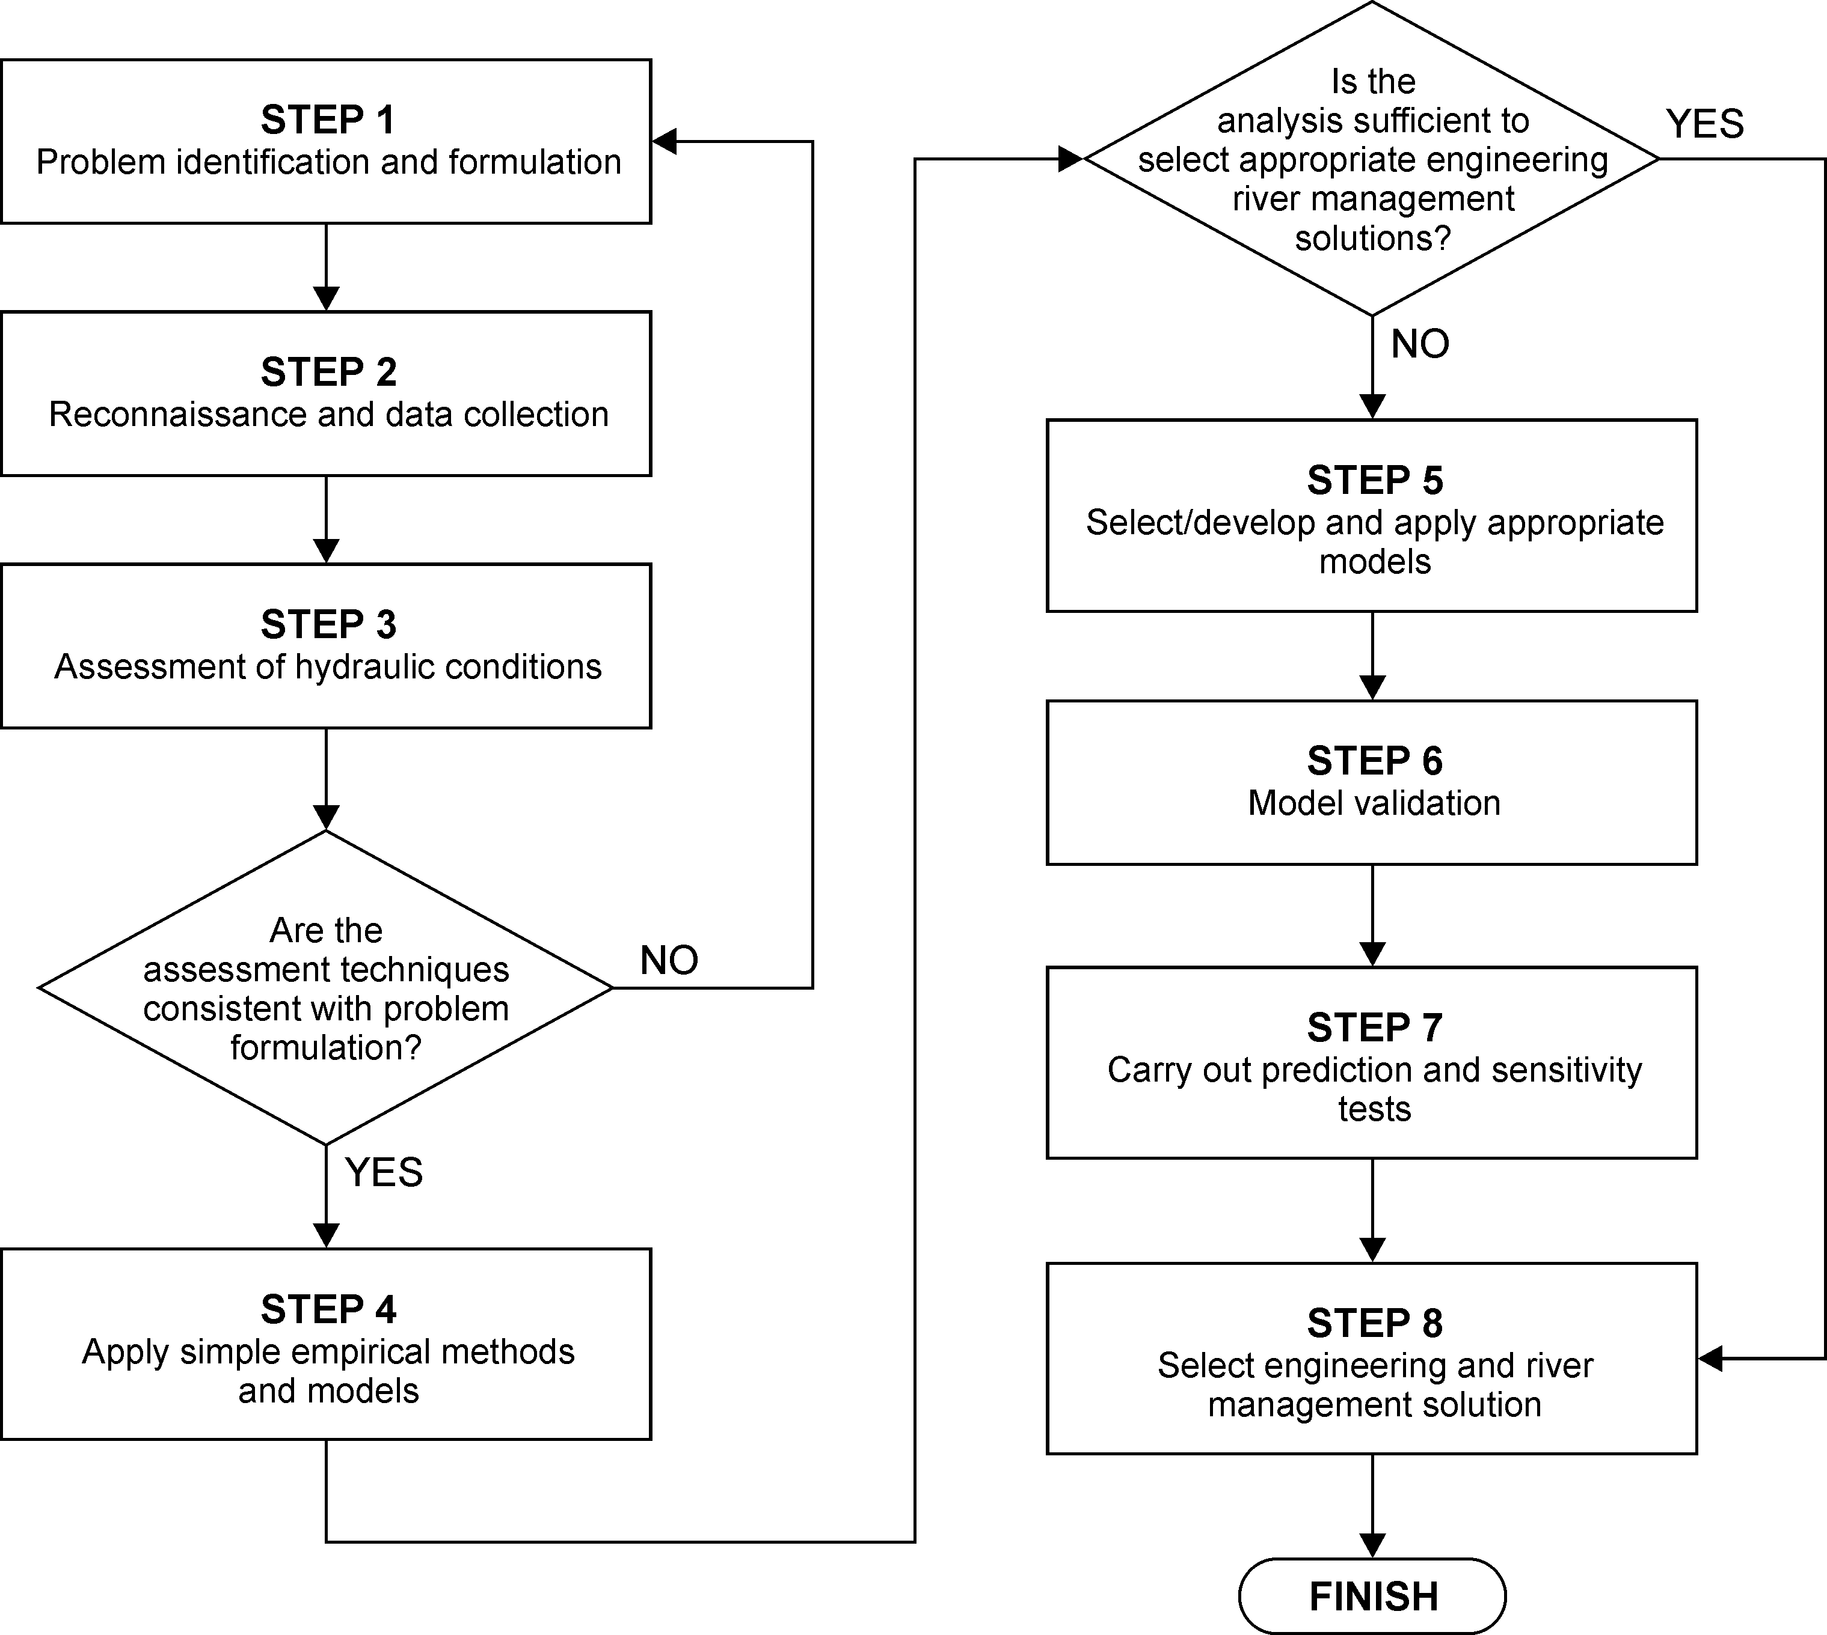

Figure 8. Procedure for the identification, analysis, and modeling of river hydraulics problems.

Step #1, problem identification and formulation, involves determining the factors at play, which may be associated with river engineering factors, social activities, and may relate to existing conditions or future activities. It establishes the level of analysis required and defines the appropriate level of response. It is followed by step #2, field reconnaissance and data collection, in order to identify the nature and extent of problem of interest. In this stage, channel characteristics are identified, bank conditions and materials, hydrologic conditions, vegetation, any engineering works, and any other parameters that are considered relevant for the case at hand. During this stage there is an assessment of the existing data available and, if necessary, it is the time to design and mount an adequate data gathering program.

At this stage, a simple assessment of the conditions should be made using basic techniques of fluvial hydraulics and geomorphology. The results of this analysis are compared with existing conditions to provide an indication of the present morphological status of the prototype. This allows the determination of the impact of the proposed engineering works.

In step #4, simple empirical channel hydraulics models are applied. This step may help to interpret existing and proposed conditions, and in identifying the dominant processes and trends at play. The information gathered at this stage forms a framework for the more detailed modeling work that follows (if appropriate). In step #5, more advanced models are developed and used, as required, to provide the more detailed information. These models should be validated with existing prototype data (step #6), and applied to current conditions and also to assess the impacts of the proposed engineering works (step #7). At this stage, a sensitivity analysis involving all the pertinent parameters should be carried out, with particular emphasis in the parameters that are difficult to determine or that have significant spatial and/or temporal variability. In step #8, all the information gathered in the previous steps is used to formulate and implement the appropriate plan of action.

USING SToRM IN MD_SWMS

The practical use of a computer model based on the SWEs involves understanding and acceptance of the limitations of the governing equations—such as the assumption of hydrostatic pressure and the implicit acceptance that the error resulting from neglecting vertical accelerations is small for phenomena having characteristic length scales much larger than the flow depth. But it also involves dealing with the numerical techniques used to solve the SWEs. The numerical solution of the SWEs is a difficult problem and involves its own level of assumptions and approximations that have direct impact on data requirements and on the accuracy of the solution. This brief primer is written to provide some assistance with the latter aspects of SToRM and assumes that the reader is already familiar enough with the former—for example, from the previous use of a model, such as FASTMECH.

In MD_SWMS, the numerical parameters used by SToRM’s numerical engine are intermingled with a number of physical parameters in a series of parameter entry screens that must be properly filled before the model can run. Here, an overview of those screens is given and guidelines to help their proper use are provided. These screens are displayed by going to the main pull-down menu in MD_SWMS and choosing SToRM > Edit Input File. There are six different entry screens: Boundary Conditions, Roughness, Initial Conditions, Environmental, Wetting and Drying, and Solution. They are selected at the left-hand side panel of the SToRM Parameters window by left-clicking the mouse on the corresponding labels.

Screen 1: Boundary Conditions

The boundary conditions properties entry screen (Fig. 9) is used to specify a number of parameters that are used by SToRM in the treatment and solution of boundary conditions. The first is the Apply Slip Boundary on/off toggle button. If selected (on), the flow velocity at solid walls and wet/dry boundaries is non-zero and tangent to those boundaries; if unselected (off), the flow velocity is set to zero at those boundaries. In general turbulent environmental flows this option should remain unselected. It is provided here to allow the simulation of inviscid laminar flow, a situation that is of interest mostly to certain laboratory and research problems.

The Velocity BC Type pull-down menu is used to select the type of boundary conditions used. In subcritical flow, flow velocity must be specified at the inflow boundary and stage (water surface elevation) must be specified at the outflow boundary. There are three ways to accomplish this in the current implementation of MD_SWMS: option Velocity Normal, where the magnitude of the flow velocity is specified at the inflow boundary; option Discharge w/Flow Depth, where the inflow discharge is specified; and option Discharge w/Flow Conveyance, which is not fully functional in SToRM but is present here as a placeholder to accommodate future model development. The first option is difficult to use appropriately: if the velocity magnitude is constant, then the discharge increases as the flow depth increases. Because this is a phenomenon with positive feedback, it should be used very carefully. It is offered here in case actual flow field measurements need to be used as boundary condition. In the most common applications, however, the discharge is known. In this case use the Discharge w/Flow Depth option. SToRM will compute a velocity profile that assumes that discharge is uniform across the inflow boundary and that it is normal to it. Note that this results in higher flow velocity in the shallower regions of the inlet, and slower velocity in the deeper regions. As with every other model, always define the boundaries away from the areas of interest to minimize the effects of the unavoidable artificial boundary effects from influencing the flow in those areas.

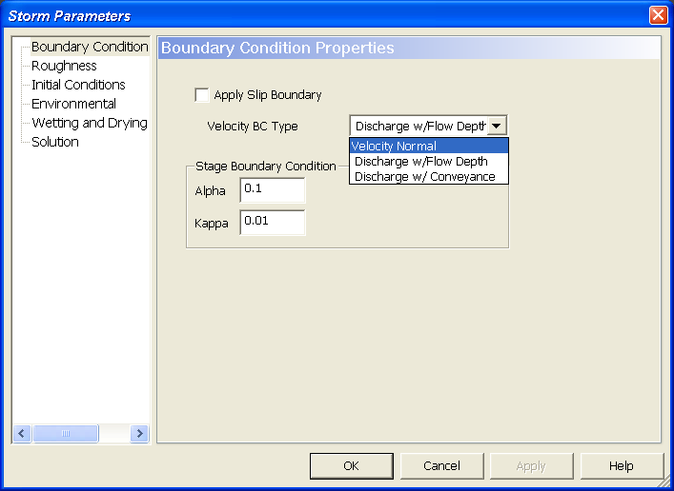

Figure 9. Boundary conditions entry screen.

The final parameters (Stage Boundary Condition) are used to relax the way the stage boundary condition at the outlet is enforced: the relaxation parameters are Alpha and Kappa. Kappa is the minimum increment allowed (to avoid infinitesimal steps). Set Kappa in the interval [0.001,0.01] for small laboratory channels, and in the interval [0.01,0.1] for larger channels and natural rivers. Alpha should be in the interval [0,1]. The recommended values are shown in Fig. 9.

Screen 2: Roughness

The Rougness entry screen (Fig. 10) is used to define the form of roughness equation (used to compute friction losses) and the desired turbulence model. Presently, there are five choices of roughness: Manning, Chézy, the traditional skin friction (drag) coefficient, Colebrook, and Strickler. All of these are traditional resistance equations and can be found in the most common literature, including recommended values of their coefficients for a number of different channel types. The last two equations use a grain size to define roughness. Roughness is a boundary condition that represents the loss of momentum caused by the channel’s bed and banks. Unfortunately, it is not a quantity that is easily measured. To compound the problem, other effects end up bundled in this coefficient (such as head losses due to recirculating eddies and to secondary flows). Therefore, the roughness parameter invariably needs calibration.

Turbulence effects are modeled in SToRM via an isotropic effective eddy diffusivity. To include turbulence effects in the calculations, check the Use Eddy Viscosity check box. The eddy diffusivity may be specified directly (check Specify Viscosity (m²/second)) or through a parameter that relates it to the water depth and shear velocity (check Use parabolic eddy viscosity (dimensionless)). The latter approach assumes a vertical logarithmic profile of the flow velocity and is commonly referred to as the ‘parabolic eddy viscosity’ (because it results in a vertical parabolic profile of the eddy viscosity). The values of the effective eddy viscosity are case dependent and can vary by many orders of magnitude, therefore they are difficult to prescribe and usually require a trial-and-error calibration procedure. It is generally easier to use the eddy viscosity parameter, which has a smaller variation range. For example, for transverse diffusivity in laboratory channels, the value of this parameter is 0.15. For irregular rivers with weak meanders, it is 0.6. For the longitudinal direction, this parameter is in the range of 140 to 500 in large rivers with complex velocity profiles, but higher values have been observed. A comprehensive discussion of the subject is outside of the scope of this overview, but can be found in many well known textbooks—see, for example, H. Fischer et al., “Mixing in inland and coastal waters,” Academic Press, New York, 1979, for a comprehensive exposition of this subject, including observed values for many small and large rivers, canals, and laboratory channels.

Note that in natural channels with complex geometries, turbulence modeling plays a role that is significantly less important than the accurate specification of the topography and other boundary conditions. The cost of more complex turbulence models may, therefore, be much larger than the returns they bring in computational accuracy.

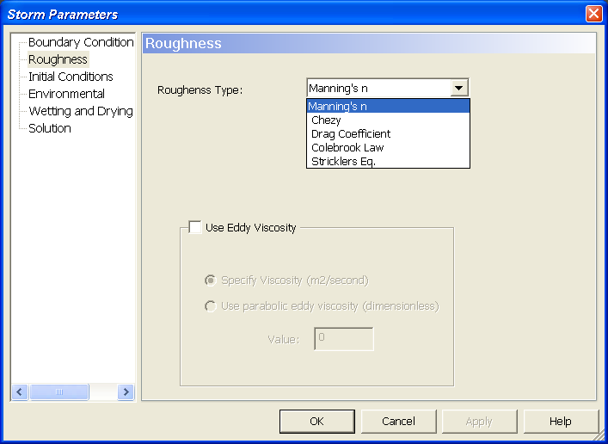

Figure 10. Roughness entry screen.

Screen 3: Initial Conditions

This screen (Fig. 11) is used to specify the initial state of the dependent variables, i.e., the values of the flow velocity and stage at time zero. In the present implementation of MD_SWMS, the entered data is used uniformly throughout the computational domain. Triangles where the bed elevation is higher that the specified water surface elevation are set to the dry state and the flow there is zero.

The closer the initial conditions are to the solution, the fewer iterations will take the model to reach steady state. Use good common sense to define these values. It is also important to have a few wet nodes at the inflow boundary. It is recommended to have a minimum of four wet nodes there. It is not important to have a wet outlet, as SToRM will route the water correctly there.

Screen 4: Environmental

This entry screen (Fig. 12) is used to enter the water temperature, in degrees centigrade. In SToRM, it is simply used to compute the laminar viscosity of water. The molecular viscosity of water is in the order of 10⁻⁵ m²/s. It is very small compared to other terms—for example, the turbulent eddy viscosity defined in screen 2 (Fig. 10) usually is several orders of magnitude greater than the laminar viscosity. This parameter is the one with least impact in the final results of any simulation. The temperature should be greater than zero degrees and lower than 100 degrees.

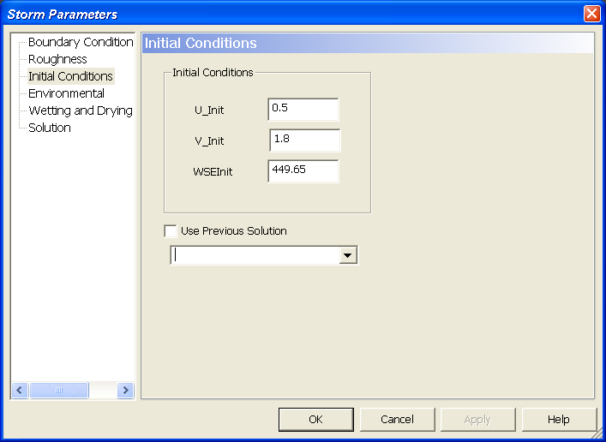

Figure 11. Initial conditions entry screen.

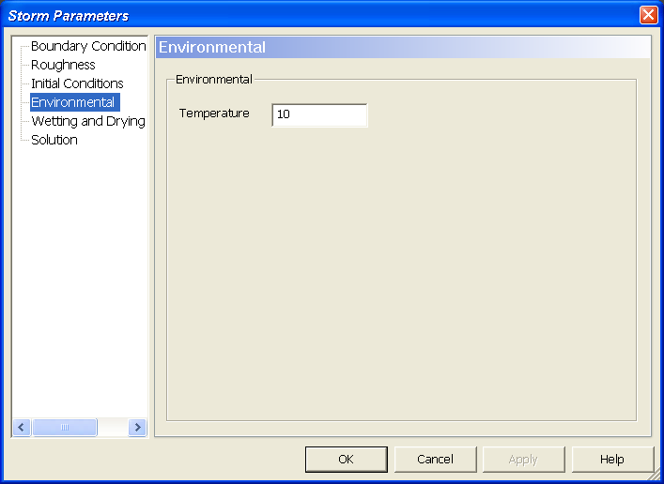

Figure 12. The temperature entry screen.

Screen 5: Wetting and Drying

The parameters defined in this entry screen (Fig. 13) determine how the wet-dry cell boundaries are treated in SToRM, and what equations to use in very shallow cells. In SToRM, cells with a water depth below a certain threshold depth are considered dry. Conservation of mass is still computed for these cells, but the velocity there is set to zero and the momentum equations are not used. This allows to track wetting and drying events, i.e., to determine when a particular cell is dry and becomes wet, and vice-versa. It also allows excluding dry cells from the computation, improving computational performance and numerical stability. Dry cells may become wet when there is a rise in the downstream stage, or as the result of a catastrophic collapse of a dam or levy. They become dry when a flood recedes. SToRM can deal with all these cases.

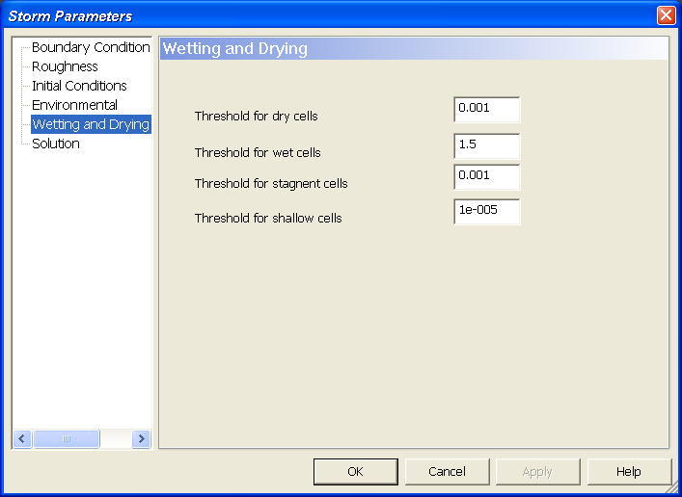

Figure 13. The parameters used to determine the wetting and drying behavior of SToRM.

The threshold for the drying of a cell (i.e., for when a wet cell becomes dry) is specified in the Threshold for dry cells parameter. This may be changed from case to case, but 1 mm is a good starting point. A higher threshold value improves stability and computational efficiency, but lower values promote accuracy. Note that all input parameters must be given in the SI system, therefore to specify a threshold of 1 mm, a value of 0.001 must be entered.

The depth threshold for when a dry cell becomes wet is defined through the Threshold for wet cells parameter. This parameter is a multiplier to the Threshold for dry cells parameter: the threshold for wet cells is obtained from Threshold for wet cells x Threshold for dry cells. For example, if the threshold for dry cells is set to 2 mm and Threshold for wet cells = 3, the value of the depth above which a dry cell becomes wet is 6 mm. A value greater or equal to 1 is allowed, but a value greater than 1 is recommended (2 is a good value). This provides hysteresis and avoids intermittent wetting and drying of cells in consecutive iterations, which adversely impacts the convergence of the solution.

The parameter Threshold for stagnant cells is not used in the current version of SToRM (version 0.3) and should be ignored.

Finally, parameter Threshold for shallow cells. SToRM has an overland flow algorithm that can be used to compute the flow in very shallow, but wet, cells. This algorithm replaces the use of the full depth-averaged momentum equations with a calculation procedure similar to the one used by watershed-scale models, which is based in the assumption that the friction forces balance the gravitational forces (i.e., the bed slope terms). The purpose of this algorithm is to allow the use of larger time steps and to accelerate convergence to steady state. The SWEs become difficult to solve numerically for shallow depths, requiring smaller time steps to keep the solution stable, thus requiring increased computation times. This algorithm relaxes those requirements for the shallow cells that it treats. Its computation is also much easier and faster than the computation required by the full momentum equations. The disadvantage in its use is that flow velocity in those cells always points in the direction of the bed slope, which may be unrealistic in some cases, especially in cells near the bank of a fast flowing river.

The use of the overland flow algorithm can be greatly beneficial in cases with large inundating or draining flood plains. Shallow depths with computational domains represented by vast amounts of triangles can result in excessively long computation times. The use of the overland flow equations can significantly reduce those times. Another potentially useful application is in the initial iterations of a simulation where steady state solutions are sought. A run can be started using larger values of the Threshold for shallow cells, which use larger time steps to march to a solution close to the desired. Then, this parameter can be reduced, the time step reduced correspondingly, and the run restarted from the previously obtained solution.

The overland flow algorithm can be turned off by specifying a Threshold for shallow cells smaller than the Threshold for dry cells (see Fig. 13).

Screen 6: Solution

The Solution entry screen (Fig. 14) contains parameters related to the main solution algorithms, including the numerical method, the iterative procedure, and the time stepping. SToRM can be used in steady-state or in time-dependent mode. To use steady-state, simply uncheck the Time Stepping Solution box. In this case, a number of techniques are used to accelerate the convergence of the solution (these are used internally by SToRM and are invisible to the user) and the Courant Number box is used to enter a Courant number. The Courant number is a stability parameter: the solution process is more stable at smaller values of this number, but takes longer to converge. It is case dependent and is usually less than 1, but values as high as 5 have been used successfully. A trial-and-error procedure is necessary to find a Courant number small enough for stability. The higher this number is, the faster a converged solution is reached. In a steady-state run, the intermediate solutions have no physical meaning.

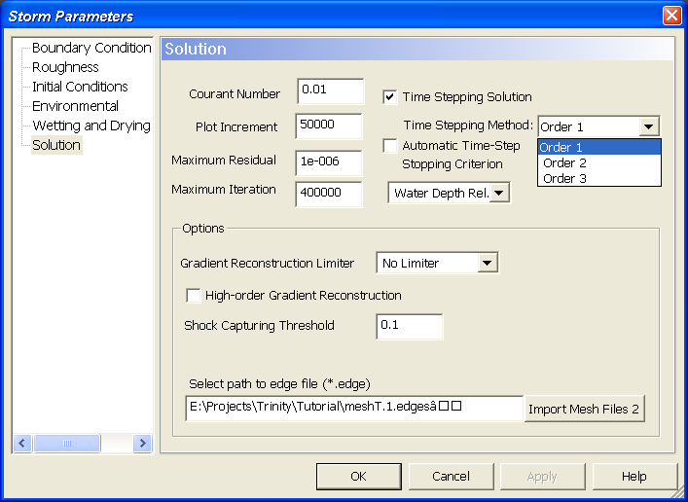

Figure 14. The Solution entry screen showing the time stepping methods used by SToRM.

If a time-dependent run is desired, the Time Stepping Solution Box must be checked. In this case there is the option of selecting an automatic time step (check the box Automatic Time-Step) and a Courant number must also be given. Once again, this number is a similar stability parameter as the one described above, but the time step is automatically chosen in each time step to be the largest possible. The benefit is that time marching may be accelerated, but a relation between the iteration number and the physical time step is lost.

A manual time stepping approach may also be chosen. In this case, the Automatic Time-Step box must remain unchecked and the time step size is entered in the Courant Number box (in seconds). For example, a time-dependent solution is selected in the screen presented in Fig. 14, using a fixed time step of 0.01 seconds.

There are three iterative marching procedures in SToRM: Order 1, Order 2, and Order 3. These can be selected under the Time Stepping Method pull-down menu and are used both in steady-state and time-dependent runs. Order 1 is the least accurate and the fastest; Order 3 is the most accurate and the slowest. In general, Order 1 can be safely used for steady-state runs. It can also be used in the first stages of a time-dependent run to march faster to a converged solution, providing a better point to start a more accurate solution process. Due to its higher accuracy, Order 2 may be used for time-dependent runs. The most accurate Order 3 could also be used in time-dependent runs, but its computational requirements make it less useful for use in many practical applications.

The main solution iterative cycle needs a criterion for stopping. In SToRM there are two criteria: if any is met, the iterations stop and the data are exported to MD_SWMS for viewing and analysis. The first criterion is simply a maximum allowed number of iterations and is specified in the Maximum Iteration window. The second criterion can be based on the residuals or on the variation of the water depth, and is set in the Stopping Criterion pull down menu (see Fig. 15). The Residual Max. Value option is based on the time-independent part of the SWEs, i.e., in the terms that do not contain time explicitly. Mathematically, these terms (called the “residual”) must balance and add to zero under steady-state conditions. They can provide an indicator regarding the convergence of the solution: the smaller the residual is, the closer the solution is to a converged and steady state. A user specified parameter, δ, is entered in the Maximum Residual box and when the residual becomes smaller than this value the iterative cycle stops. A good starting point for δ is 10⁻⁶.

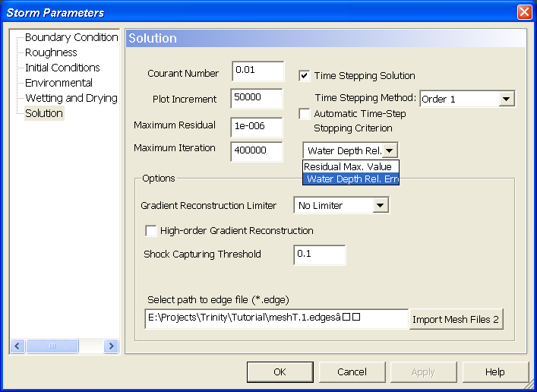

Figure 15. The stopping criteria used in SToRM.

The second option is called Water Depth Rel. Error and is based in the root mean square E of the variation of the water depth from one iteration to the next, and the iterative cycle stops when this value becomes smaller than a user specified parameter:
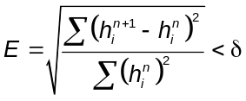
where h is the water depth, the superscript refers to the iteration number, and the subscript i is the summation index (summation is carried over the entire computational domain). Parameter δ is entered in the Maximum Residual window.

Setting the magnitude of δ (δ is a positive parameter larger than zero regardless of the stopping criterion chosen) is problematic. For example, the residuals can be very small throughout most of the domain, indicating a converged solution. However, wetting or drying cells have a very large residual. Because the convergence indicator uses the maximum residual in the entire computational domain, a single wetting or drying cell can prevent the convergence criterion from stopping the run. Although this is a phenomenon that is somewhat mitigated by the use of hysteresis in the water depth thresholds for drying and wetting, there are others that may have an equally detrimental effect on the convergence indicator. Similar considerations may be made about E. To compound the problem, a small value of the residual, or of E, doesn’t necessarily mean that the solution has converged: it may simply be converging very slowly. Therefore, it is ultimately the user’s responsibility to ensure that the final solution has converged. This can be done, for example, by looking at solutions at different iterations (or time steps) and stopping the run when the solution doesn’t change significantly. Intermediate output of SToRM solutions can be done by specifying a plotting interval in Plotting Increment window.

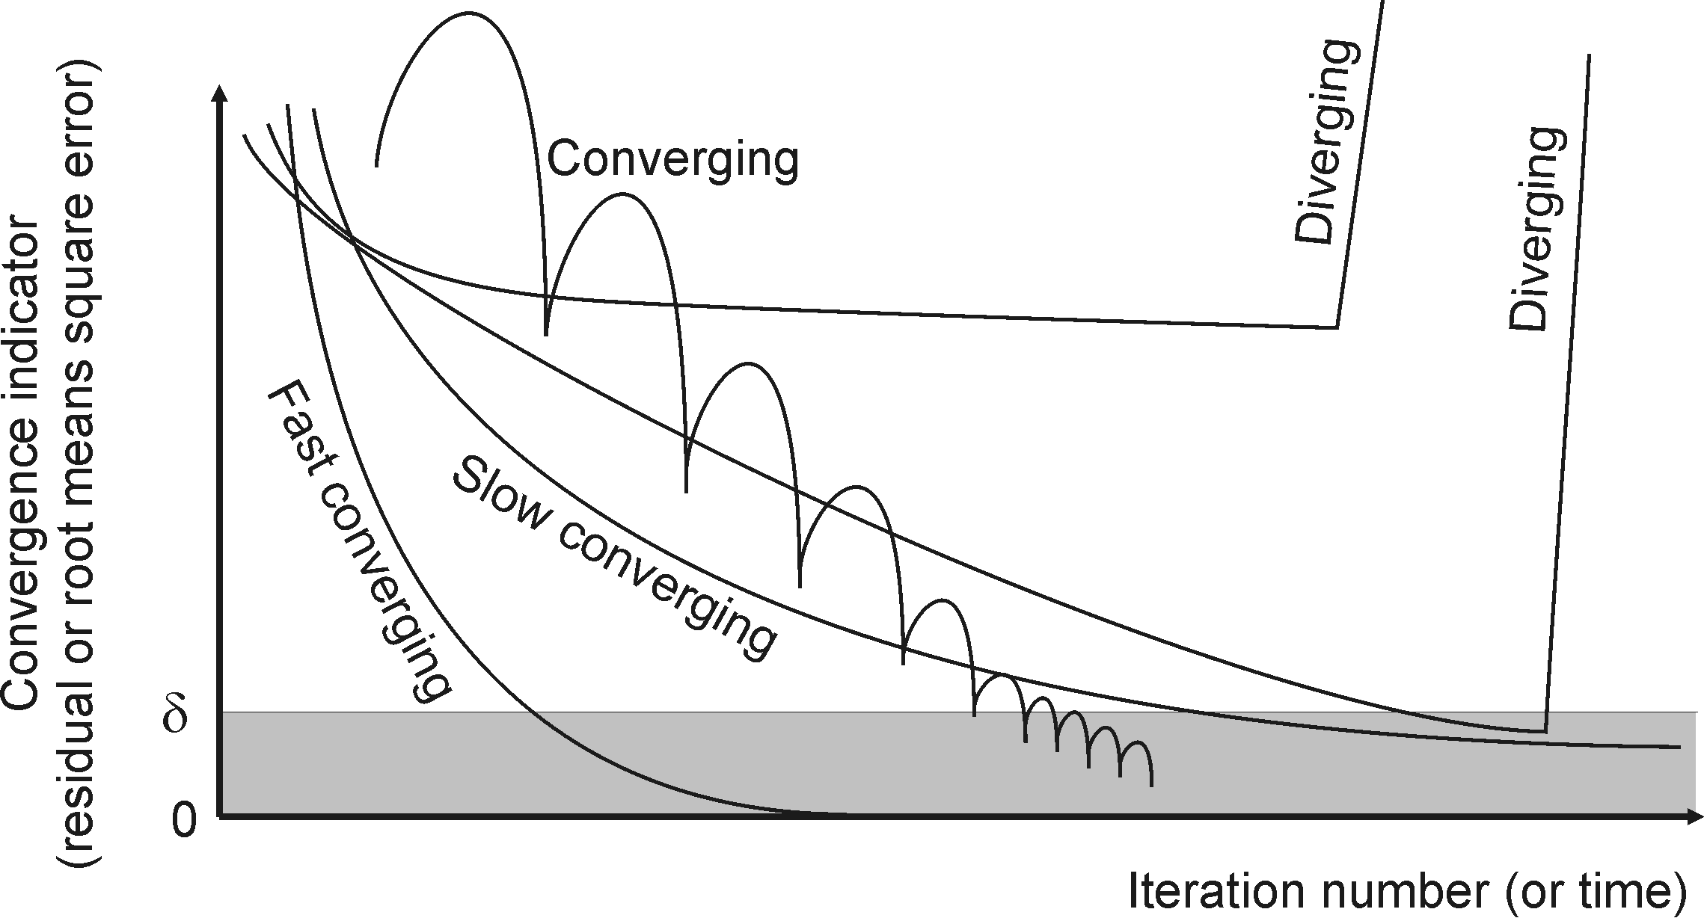

Figure 16. Possible behavior of the convergence indicator in SToRM. The iterative process is stopped when the convergence indicator becomes smaller than δ. The gray box shows what the behavior of the iterative cycle would be if SToRM didn’t stop at the δ threshold.

SToRM has several methods to compute the solution variables’ gradients. This is generally called the “gradient reconstruction” procedure. The gradients of the water depth and flow velocity are important components of the solution algorithm in any numerical model of the SWEs. In MD_SWMS, the method used for gradient reconstruction is chosen in the Gradient Reconstruction Limiter pull-down menu of the Solution entry screen (Fig. 17). When Zero Gradient is chosen, the flow variables are treated as constant within each computational cell, resulting in a computationally expedient method, but with low accuracy. It can be used to produce a hot start for a more accurate method when the initial conditions are poor and far from the desired solution. The No Limiter method is accurate and robust for most applications. When there are very sharp gradients in the solution, such as those encountered in hydraulic jumps or in dam break flows, spurious oscillations may be present in the solution (also commonly referred to as wiggles). When that happens, select the Barth Jespersen method to avoid those oscillations. This latter method is the most robust, but is also the one most computationally expensive.

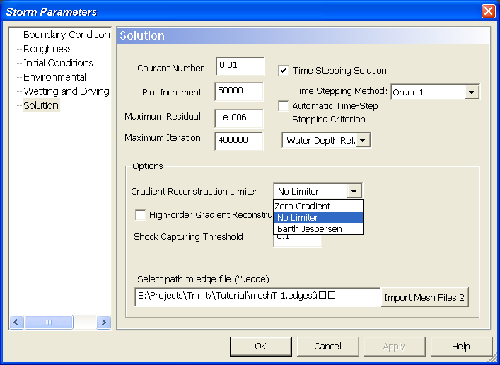

Figure 17. The types of gradient reconstruction used in SToRM.

The High-order Gradient Reconstruction check box allows SToRM to use a larger computational molecule. The set of nodes used to compute the solution gradients is called the computational molecule. Usually, the more nodes used, the more accurate the gradient. Fig. 18 shows the nodes used in possible computational molecules in structured and unstructured models. The open circle shows the location where the gradients are to be computed. If Zero Gradient is used (variables constant within the cell) only one node needs to be used and no further considerations are necessary. However, if a more accurate reconstruction is sought (No Limiter or Barth Jespersen), there are several possible choices. SToRM uses the configuration shown at the right of Fig. 18. When the High Order Reconstruction Box is unchecked, only the closest neighbors are used (light gray circles). This constitutes a compact computational molecule that is computationally very efficient. If the High Order Reconstruction Box is checked, the computational molecule is enlarged to include the second neighbors, resulting in a larger, but potentially more accurate computation of the gradients. This option is offered in the hope that it may permit the use of coarse grids for equally accurate solutions (when compared to those obtained by the smaller molecule on finer grids). Unfortunately, this depends on multiple factors, such as grid quality and features in the topography, and is not a guaranteed result.

Finally, a comment about the Shock Capturing Threshold. SToRM uses one of two methods to calculate the convective terms of the SWEs. One method has a very good shock capturing ability (shock-capturing scheme), the other is very good for smooth flows without discontinuities and runs faster (diffusive scheme). Both methods are used simultaneously during a run, but the idea is to run the shock-capturing scheme only across shocks, such as hydraulic jumps and in wetting and drying boundaries. This is accomplished by the use of parameter Shock Capturing Threshold: if the water depth across a triangle’s edge is larger than this parameter, then the shock-capturing scheme is used, otherwise the diffusive scheme is used instead. This parameter is actually a percentage and varies between 0 and 1. In Fig. 14 it is set to 10%, meaning that the shock-capturing scheme is used for all edges that have a variation of more than 10 % in the water depth. The shock-capturing scheme can be turned off completely by setting the Shock Capturing Threshold to 1. Similarly, the diffusive scheme can be turned off by setting this parameter equal to zero. As with many options in SToRM, this parameter is an attempt to improve computational efficiency: the shock-capturing scheme allows sharper gradients at the expense of increased computational effort. But as the saying goes, you cannot have the cake and eat it too: any improvement in one aspect comes at the cost of another.

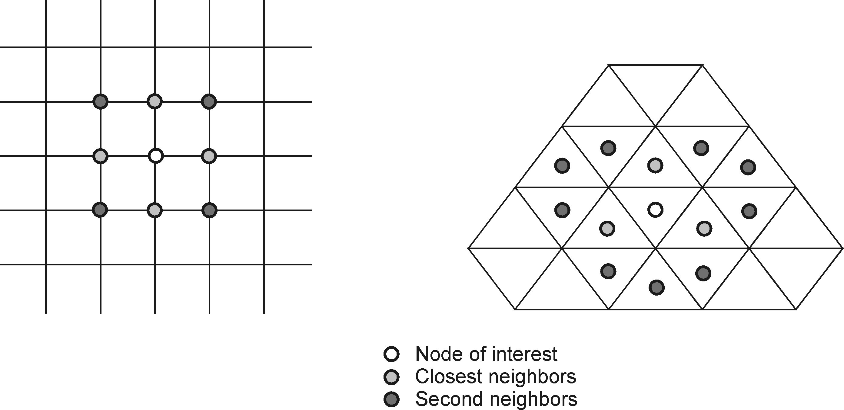

Figure 18. Computational molecule used in structured (left) and unstructured (right) grid models.

FURTHER CONSIDERATIONS

Experience in using computer models and good engineering judgment are the most important elements when using any computer model. Together, they provide a roadmap of what to expect from a particular model run and how to brainstorm unexpected results. That cannot be taught in a short monograph such as this one, but the next remarks may be useful when using SToRM.

SToRM uses a numerical discretization based on triangles of constant slope. It uses a control volume formulation in which the control volumes are triangles and the dependent variables (flow velocity and depth) are defined at the triangles’ centers. Triangular unstructured grids may be less intuitive to use that the more usual structured grids, such as the one used in FASTMECH. An example on how a wet-dry boundary could be represented by the two types of discretization is shown in Fig. 19. Both have advantages and disadvantages: models that use structured grids are usually computationally more efficient (i.e., they require shorter computational run time for grids of comparable size), but unstructured grids can make a better use of local refinement and provide a more accurate representation of the topography.

A particularly difficult issue is the generation of computational grids for the arbitrarily shaped channels and irregular topographies usually encountered in natural rivers. The river channel and adjacent flood plains have a continuous nature that becomes discontinuous when discretized. The features captured in any discretization are determined by the size and placement of the computational cells: smaller triangles capture more features at the expense of more computational effort in computer memory and run time. Thus, the grid size defines a scale that ultimately controls the nature of the model predictions and the results need to be interpreted accordingly. But there must be a proper balance: at coarse grids the model may be unable to resolve the flow features or even produce converged solutions, but at finer grids the computational requirements may be too demanding. Note also that when the computational grid is finer than the topographic resolution, the model predictions become hostage to the nature of the topographic interpolation without representing any real topographic variation. Therefore, the data collection program should be guided by the modeling objectives, and the modeling efforts must be consistent with the data collected.

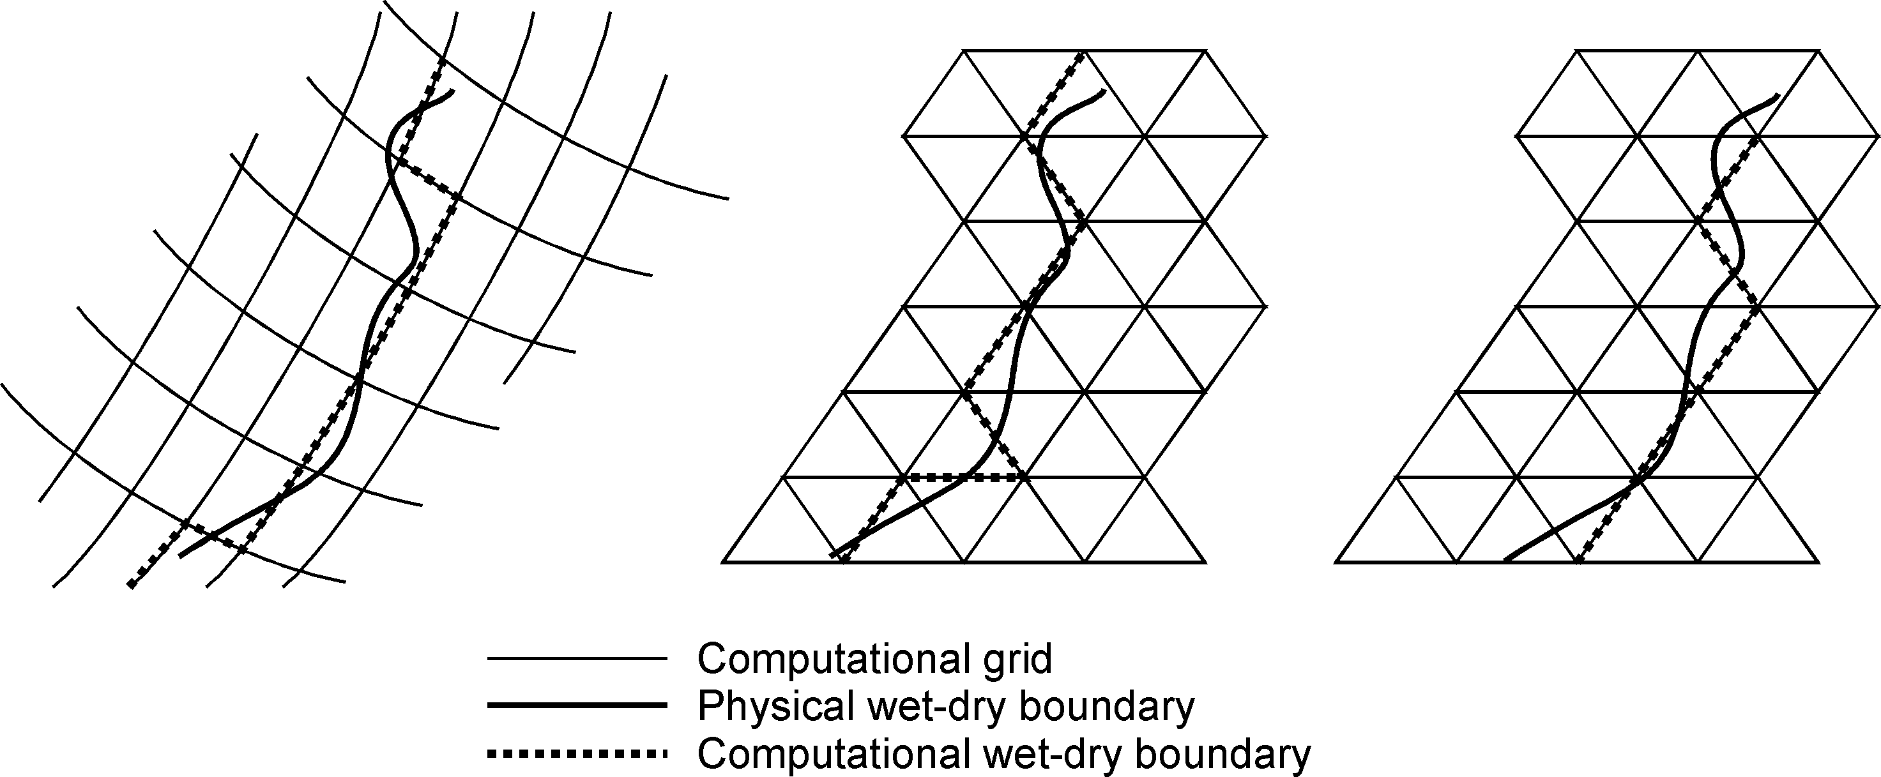

Figure 19. Representation of a physical boundary (a river bank) by a structured rectangular curvilinear grid (left) and by unstructured triangular grids with approximately the same cell size, in area, but placed in different locations (center and right).

MD_SWMS provides a number of tools to help in grid generation and feature representation. Those should be used to their full extent, but in a manner consistent with the topographic data. A starting rule of thumb is to use 8 to 10 triangle edges across any feature that needs to be resolved—for example, across a river’s cross-section, or across a recirculation area, or behind an obstacle… Local refinement may be useful to accomplish this. Improve computational efficiency by removing triangles that do not contribute to the solution (SToRM accepts holes and any type of irregular boundaries). MD_SWMS allows defining sharp breaks in bed slope: use those tools to place triangle edges where they can provide the most resolution at the smallest cost. Finally, note that SToRM treats all outer edges (other than at inflow or outflow boundaries) as solid walls, therefore water will not spill out of the computational domain in those areas. Use them to define features like levees, abutments, vertical walls, etc.

The iterative methods used in SToRM are explicit in nature. In practical terms, this means that there are certain constraints that must be verified in order to keep the computations stable. If not, the computations “blow up,” which is a way to say that the variables become uncontrollably large (or small), cause divisions by zero, so that the water depth may become negative, the run stops prematurely, and its results are meaningless. Usually, in convection-dominated flows, stability is related to flow celerity, size of the time step, and triangle dimension by a dimensionless parameter:
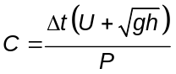
where Δt is the time step size, U is the magnitude of the flow velocity at the center of the triangle 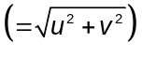, h is the water depth at the same point, g is the acceleration due to gravity (9.8 m/s²), and P is a length scale (for example, the triangle’s perimeter). The dimensionless parameter C is called the Courant number and is fixed for a certain time stepping method, but usually different for different methods. The above relation translates into the flowing statements:

- For a triangle of a certain size, larger flow velocity requires smaller time steps.
- In the same situation, larger depths also require smaller time steps, but this constraint is less severe than the one for flow velocity.
- Larger time steps can be used for larger triangles. For smaller triangles the time step size must be reduced accordingly.

These are important facts to keep in mind when selecting the parameters that go into the Solution entry screen. Unfortunately, things are not that simple. For example, for shallow depths the friction terms become dominant, the flow is no longer convection-dominated, and new restrictions are imposed to the time step to keep the computations stable: small time steps are needed for very shallow depths. Therefore, a trial-and-error cycle is usually necessary to determine the largest time step that retains the stability of the computations. This is case dependent and varies with bed geometry and other boundary conditions.

Each situation is different. Regardless of the particular model used, most parameters are case dependent and require their own tuning. Through use, this process becomes somewhat more intuitive.

Francisco J.M. Simões
USGS Geomorphology and Sediment Transport Laboratory
4620 Technology Drive, Suite 400
Golden, CO 80403
Phone 303.278.7956 (Fax 303.279.4165)
E-mail frsimoes@usgs.gov
http://wwwbrr.cr.usgs.gov/gstl/

